**Lecture 28 – Plant Nutrition and Development**

* Plants need light, CO2, water, minerals and nutrients for development and reproduction
  + Above ground: ( ) and ( ) (photosynthesis)
  + Below ground: ( ) and ( )
  + Essential elements: required to complete life cycle and produce another generation
* Plants require nutrients in different quantities
  + ( ): Required in large amounts (carbon, oxygen, hydrogen, nitrogen, potassium, calcium, magnesium, phosphorus, sulfur)
  + ( ): Required in small amounts (chlorine, iron, manganese, boron, zinc, copper, nickel, molybdenum)
* Shoot system generates ( ) through photosynthesis
  + 6 CO2 + 6H2O + Light energy = C6H12O6 + 6 O2
* Resource acquisition and transport involve both root system and shoot system (understand the function of different organs in resource acquisition and transport) (Fig. 36.2)
* There are two different mechanisms of transportation in plants
  + Short-distance Transport
    - Solute across plasma membrane (diffusion, active transport)
    - Water across plasma membrane (diffusion)
  + Long-distance Transport
    - Bulk flow (pressure gradient)
* Plant tissues have two major compartments (Fig. 36.6)
  + ( ): everything external to plasma membrane (cell walls, extracellular spaces, interior of dead cells)
  + ( ): entire mass of cytosol of living cells, plasmodesmata, cytoplasmic channels
* Compartmental structure of plant cells provides three routes of transportation
  + ( ) route: water and solute move along *continuum formed by cell walls, extracellular spaces, dead interiors of tracheids and vessels*
  + ( ) route: water and solute move along *continuum of cytosol of cells, connected by plasmodesmata*
  + ( ) route: water and solute move *out of one cell, across the cell wall, and into the neighboring cell*
* Short-distance transport of water is due to diffusion (osmosis)
  + Transport of water molecules across membranes is facilitated by transport proteins called ( ).
* Short-distance transport of solute across plasma membranes mostly relies on ( )
  + In active transport in plant cells, the most important transport proteins are proton pumps, which use energy from ATP to pump ( ) out of the cell. (Fig. 36.7)
  + Proton pump can also cotransport other solutes.
    - Examples:
* Transport of water and minerals from root hairs to xylem relies on ( ) and

( ) (Fig. 36.10)

* ( ) (innermost layer of cells in root cortex): last checkpoint for the selective passage of minerals
* ( ): a belt made of suberin (waxy substance), preventing water and minerals from entering stele through ( ) pathway

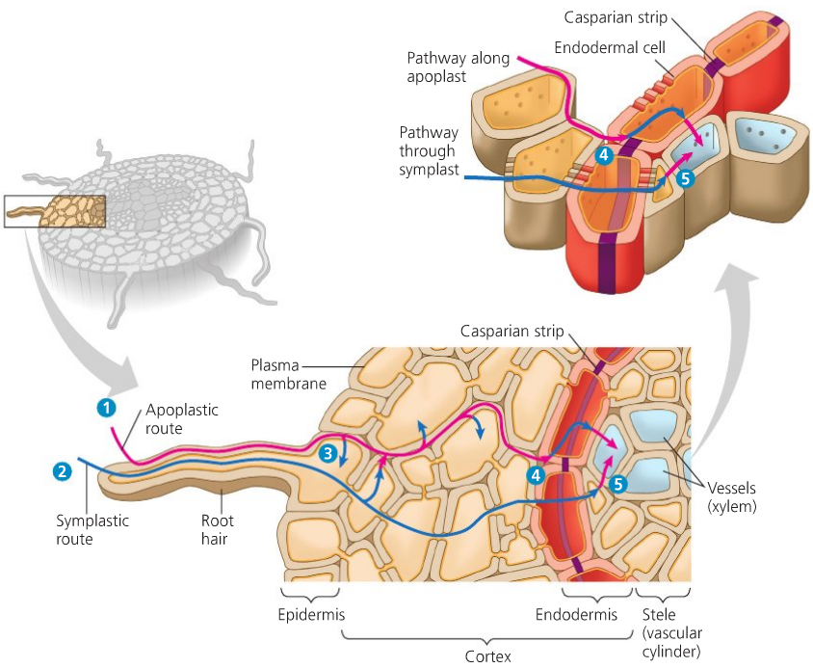

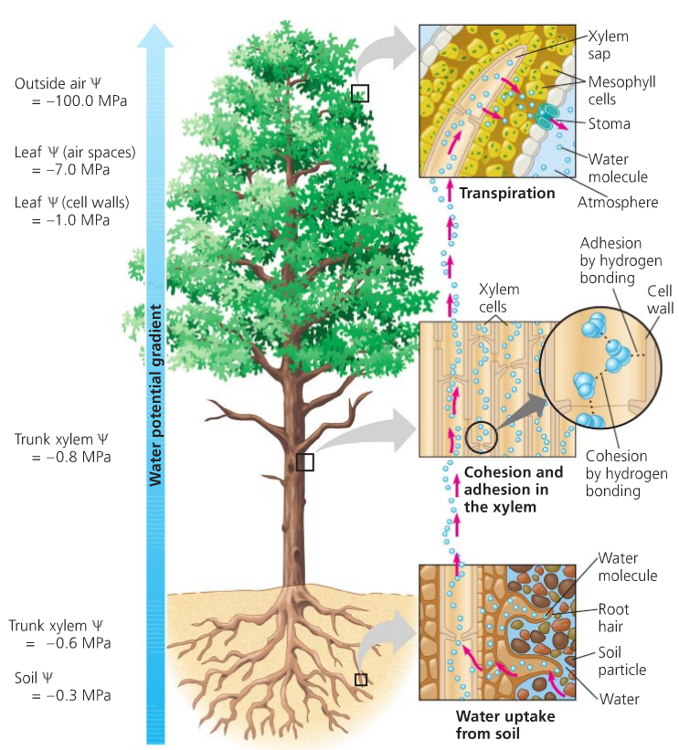

* Bulk flow in xylem is powered by transpiration, cohesion, adhesion, and tension
  + Upward movement by ( ) pressure from above
  + ( ): loss of water vapor from leaves and other aerial parts of the plant
  + ( ): hydrogen bonding between water molecules
  + ( ): hydrogen bonding between water molecules and cell walls
  + ( ): negative pressure potential
* Stomata regulate transpiration
  + 95% water loss through stomata
  + Stomatal opening and closing depend on ( ) and ( ) movement in guard cells
  + Stomata affected by light, CO2 depletion, and internal “clock”
* Sugars are transported from ( ) to ( ) via the ( )
  + Sugar ( ): plant organ that is a net producer of sugar by photosynthesis or by breakdown of starch
  + Sugar ( ): plant organ that is a net consumer or depository of sugar
  + ( ): transport of the products of photosynthesis
  + Phloem sap: aqueous solution that flows through sieve tubes (up to 30% sucrose)
* Plants have alternation of generations
  + Alternation of generations: multicellular haploid (n) and diploid (2n) generations take turns producing each other

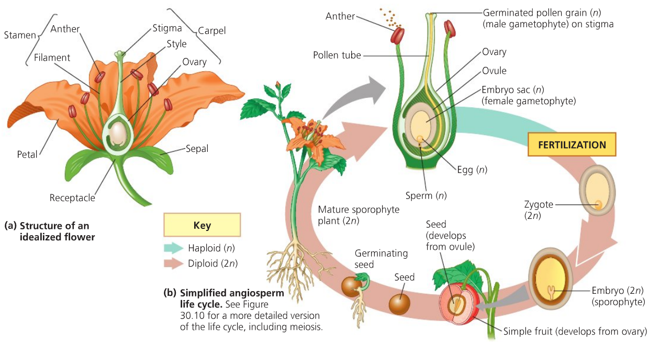

* Differences in male and female gametophyte generation (Study Fig. 38.3)
  + Male: Microsporangium (pollen sac) 🡪 Microsporocytes (2n) 🡪 4 Microspores (n) 🡪 Pollen grain (n) (generative cell and tube cell)
  + Female: Megasporangium (within ovule) 🡪 Megasporocyte (2n) 🡪 4 daughter cells (n), but only one megaspore (n) 🡪 3 mitosis 🡪 8 haploid nuclei (n), which collectively give rise to embryo sac
* Pollination is the process by which pollen is transferred in the reproduction of plants, enabling fertilization and sexual reproduction.
  + There are many different ways of pollinating plants.
    - Examples:
* Angiosperms use double fertilization (Fig. 38.6)
  1. Pollen grain lands on stigma, it absorbs water and germinates by producing

( )

* 1. Pollen tube grows down style toward ovary
  2. Pollen tube discharges ( ) sperm into ( )
  3. One sperm fertilizes the egg, forming zygote
  4. The other sperm combines with two polar nuclei, forming triploid ( ) (food storing tissue of the seed)
  5. ( ): union of two sperm cells with different nuclei of the female gametophyte
* After double fertilization, ovule develops into a ( ) and ovary develops into a

( )

* + Seed stockpiles proteins, oils, and starch to nourish the embryo
  + Fruit protects the enclosed seeds and aids in their dispersal by wind or animals
* Plants disperse their offspring in different ways.
  + Examples: